* An electric vehicle (EV) runs on an electric motor rather than an internal-combustion engine that creates power by burning a mixture of gasoline and gases.
* In the working the controller collects and manages electricity from batteries and inverters. When the controller is activated, the inverter transmits a certain quantity of electrical energy to the motor. Electrical energy is converted into mechanical energy by an electric motor. The rotation of the motor rotor turns the gearbox, causing the wheels to revolve and the automobile to move.

Types of Electric Vehicles

* Battery Electric Vehicle
* Hybrid Electric Vehicle
* Plug in Hybrid Electric Vehicle
* Fuel cell Electric Vehicle

Battery Electric Vehicle(BEV)

* A Battery Electric Vehicle (BEV), sometimes known as an All-Electric Vehicle (AEV), is a vehicle that is driven by a battery and an electric drive train. These EVs do not have an IC Engine. Electricity is stored in a huge battery pack, which is charged by connecting to the power grid. In turn, the battery pack powers one or more electric motors that power the electric vehicle.
* Main components of it are batteries, control module, drive train, electric motor and inverter. For the electric motor, power is transformed from the Direct Current battery to alternating current. The accelerator pedal sends a signal to the controller, which modifies the frequency of the AC flowing from the inverter to the motor to regulate the vehicle’s speed.
* The motor connects to and rotates the wheels through a gear. When the brakes are applied or the electric vehicle is decelerating, the motor transforms into an alternator and generates electricity, which is then returned to the battery.
* Some of examples are BMW i3, Toyota Rav4, Kia Soul

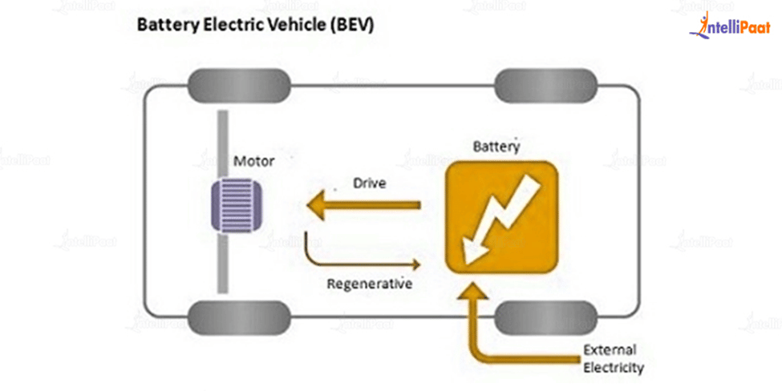

Hybrid Electric Vehicle(HEV)

* The HEVs are operated by both an  IC Engine and an electric motor. In these sorts of electric vehicles, the internal combustion engine is powered by fuel (gasoline and other forms of fuel), while the motor is powered by batteries. The gasoline engine and electric motor rotate the gearbox, which drives the wheels, at the same time.

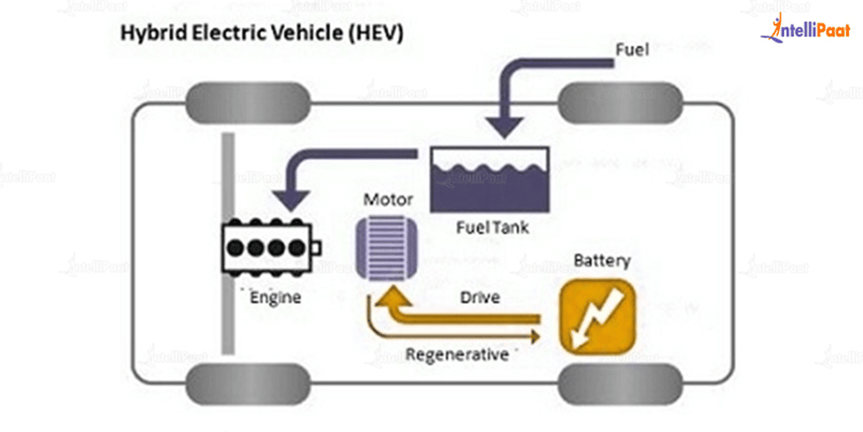

* The components of HEV are battery pack with controller and inverter, control module, engine, electric motor, fuel tank
* Similar to a standard automobile that has a fuel tank that delivers gas to the engine. It also contains a battery pack that powers an electric motor.
* Examples are Toyota Prius Hybrid and Toyota Camry Hybrid

Plug In Hybrid Electric Vehicle

* A PHEV is a hybrid vehicle that has both an ICE and a motor, often known as a series hybrid. This sort of electric automobile comes with a variety of fuel options. This type of electric vehicle is propelled by a conventional fuel (such as gasoline) or an alternative fuel (such as biodiesel), as well as a rechargeable battery pack.
* The battery can be charged by connecting it to an electrical outlet or an electric car charging station (EVCS).
* PHEV has normally two modes of operation they are Allele citric Mode, in which the motor and battery supply all of the energy for the vehicle and Hybrid Mode, in which both electricity and fuel are used.

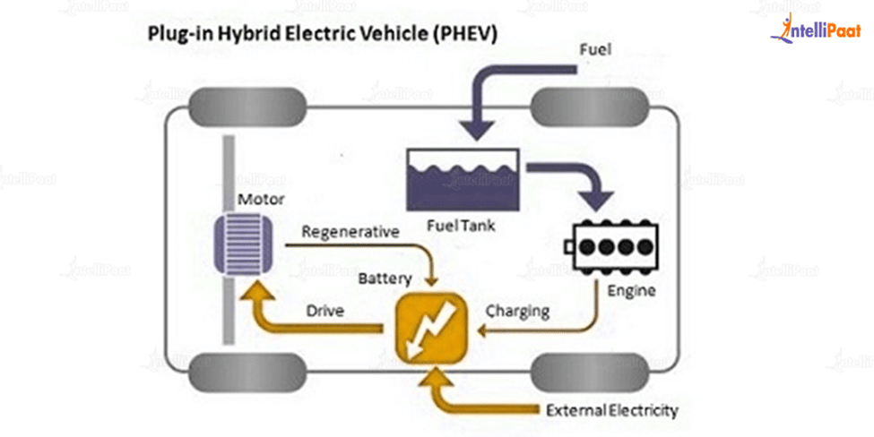

* Main components of PHEV are battery, battery charger ,control module, electric motor, engine, fuel tank and engine
* PHEVs normally start in all-electric mode and run on energy until their battery pack runs out of juice. When certain models reach highway cruising speeds of 60 or 70 miles per hour, they switch to hybrid mode.
* When the battery runs out, the engine kicks in and the car works as a standard, non-plug-in hybrid. PHEV batteries can be charged by an internal combustion engine or regenerative braking, in addition to connecting to an external electric power source.
* During braking, the electric motor functions as a generator, transferring energy to the battery. Because the electric motor supports the engine’s power, smaller engines can be used, enhancing fuel efficiency without sacrificing performance.
* Examples are Mercedes GLE550e, BMW 330e

Fuel Cell Electric Vehicle

* Fuel Cell Electric Vehicles (FCEVs), also known as fuel cell vehicles (FCVs) or Zero Emission Vehicles, are electric vehicles that use “Fuel Cell Technology” to create the electricity needed to power the vehicle. The chemical energy of the gasoline is turned directly into electric energy in this sort of vehicle.
* Main Components of FCEV are battery with converter and controller, hydrogen storage tank, Electric motor and fuel cell stack
* The operation of a ‘fuel cell’ electric car differs from that of a ‘plug-in’ electric vehicle. This sort of electric car exists because the FCEV creates the electricity needed to power the vehicle.
* Examples are Hyundai Tucson FCEV, Honda Clarity Fuel cell, Toyota Mirai, Hyundai Nexo

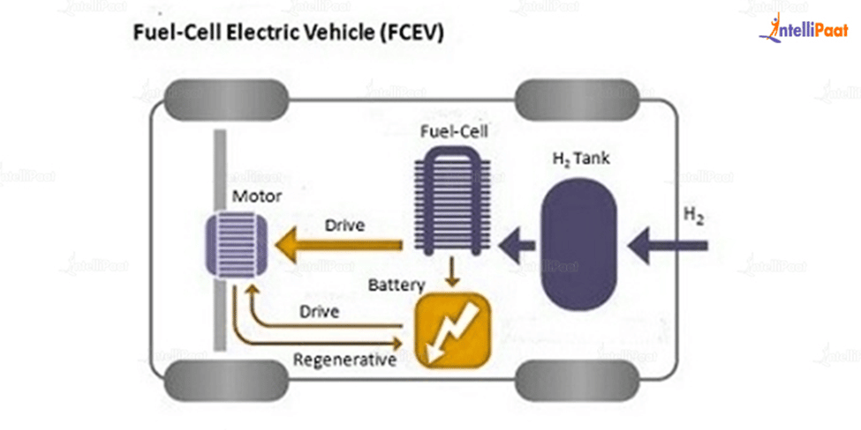

Electrical Passenger Cars

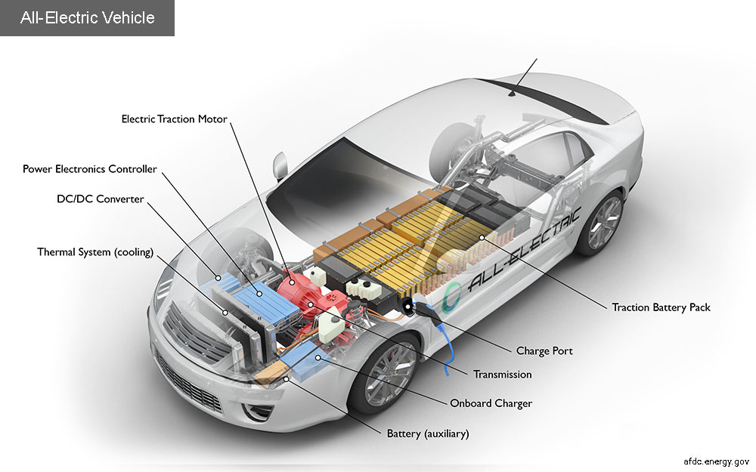

* Battery: In an electric drive vehicle, the auxiliary battery provides electricity to power vehicle accessories.
* Charge port: It allows vehicles to connect to an external power supply in order to charge the traction battery pack
* DC-DC convertor: this device converts higher voltage dc power from traction battery pack to lower voltage dc power needed to run the accessories of the vehicle.
* Electric Traction motor: Using power from the traction battery pack this motor drives the vehicle wheel
* Onboard Charger: Takes the incoming electricity via charging ports and converts it to DC power for Charging the traction Battery. It also communicates with the charging equipment and monitors and battery characteristics such as voltage, current, temperature, state of charge during charging the pack.
* Power Electronics Controller: This unit manages the flow of Electrical energy delivered by the traction battery controlling the speed of traction motor and the torque it produces
* Thermal System (Cooling): This system maintains proper operating temperature range of engine, electric motor, power electronics devices and other components
* Transmission: The transmission transfers mechanical energy from the electric motor to drive the wheels

Specification Volvo 7900 Electric

Dimensions and weights

|  |  |  |  |
| --- | --- | --- | --- |
| Model | 12.0 m | 18.0 m | 18.7 m |
| Length (m) | 12 | 17.8 | 18.5 |
| Width (m) | 2.5 | 2.5 | 2.5 |
| Height (m) | 3.3 | 3.3 | 3.3 |
| Permitted GVW (kg) | 19 500 | 30 000 | 30 000 |

Passenger capacity

|  |  |  |  |
| --- | --- | --- | --- |
| Model | 12.0 m | 18.0 m | 18.7 m |
| No. of passengers | 95 | 150 | 145 |

Driveline

|  |  |  |  |
| --- | --- | --- | --- |
| Model | 12.0 m | 18.0 m | 18.7 m |
| Electric motor, output max (kW) | 200 | 2x200 | 2x200 |
| Max wheel torque (Nm) | 19,000 | 31,000 | 31,000 |
| Gearbox | 2-speed automated manual transmission | | |

Charging*

|  |  |  |  |
| --- | --- | --- | --- |
| Model | 12.0 m | 18.0 m | 18.7 m |
| Roof charging: OppCharge and panto up (roof-mounted pantograph), max charge power (kW) | 300 | 400 | 450 |
| CCS max charge power (kW) | 150 | 150 | 150 |

* Max charge power depending on configuration of the energy storage system.

Axles and steering

|  |  |
| --- | --- |
| Front axle | Volvo rigid low beam axle |
| Rear axle | ZF AV133 |
| Steering | Electrically powered hydraulic steering Volvo Dynamic Steering as option |

Brakes

|  |  |
| --- | --- |
| Brake systems | Volvo disc brakes Electronic Braking System (EBS5) Anti-lock Braking System (ABS) Acceleration Slip Regulator (ASR) Brake blending Hill start aid Electronic Stability Program (ESP) as option on 12.0 m |

Tata Ultra T7 Electric Truck

Performance

|  |  |
| --- | --- |
| Engine Norm | Zero Tailpipe |
| Max Torque | 2800 NM |
| Max Speed | 80 KMPH |
| No. of Tyres | 6 |
| GVW | 7490 - 8750 KG |
| Payload | 3692 - 4935 KG |
| Load Body Size | HDLB, CLB and CABIN CHASSIS |
| Kerb Weight | 3798 - 3815 KG |
| Range | 100 km per charge |

Dimensions

|  |  |
| --- | --- |
| Length | 6400 MM |
| Wheelbase | 3550 - 3900 MM |
| Minimum Turning Radius | 6950 MM |

Brake Suspension

|  |  |
| --- | --- |
| Brakes | Air Brakes 325 X 120 S – CAM, Drum Brakes |
| Front Axle | I beam with Air Drum Brakes |
| Rear Axle | RAS 104, Salisbury with Air Drum Brakes |
| Front Suspension | Parabolic springs with antiroll bar |
| Rear Suspension | Semi-Elliptical Leaf Springs with parabolic auxiliary |

Clutch Transmission

|  |  |
| --- | --- |
| Clutch | Single plate dry friction type 310mm dia |
| Steering | Intergrated hydraulic power steering |
| Transmission | Automatic drive |

Body cabin

|  |  |
| --- | --- |
| Cabin Type | Ultra Narrow Cab |

Tyre

|  |  |
| --- | --- |
| Front Tyre | Radial tyres , 235/75 R 17.5 Tubeless,Al alloy wheels , 6.75 X 17.5 |
| Rear Tyre | Radial tyres , 235/75 R 17.5 Tubeless,Al alloy wheels , 6.75 X 17.5 |

Charging

|  |  |
| --- | --- |
| Charging Time | 2 hours (approx.) |
| Charger Type | Off Board DC Fast Charging |
| Battery Capacity | 62.5 Kwh |

Others

|  |  |
| --- | --- |
| Seat Type | Standard |
| Seating Capacity | Driver + 2 Passenger |
| Battery | 24V system |
| Adjustable Driver Seat | yes |
| Gradeability | 26 (%) |